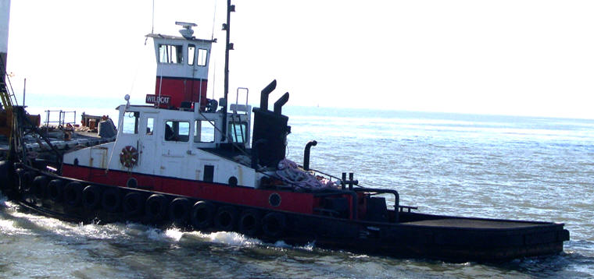

Horsepower: | Length: | Beam: | Deep Draft: | Astern Bollard: | Ahead Bollard:
880/Single Push Knee | 56’ | 15’ | 5’ | 15.17 Kips | 19.77 Kips
Engines: | Face Wires: |  |  | Fresh Water: | Fuel Oil:
Twin Cummins  N14M | 7/8x75’
Propellers: | Tow Winch: |  |  | Bow Winch:
Twin Nozzles
Gross Tonnage: | Call Sign: |  |  | Official Number:
30 | WCY5209 |  |  | 269531
Note:

