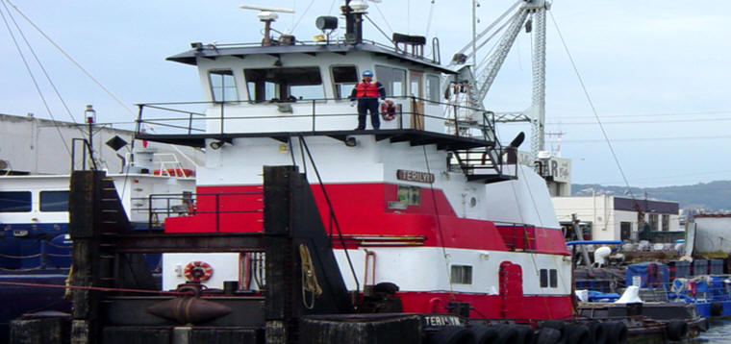

Horsepower: | Length: | Beam: | Deep Draft: | Astern Bollard: | Ahead Bollard:
1,550 | 70’5” | 26’ | 8’5” | 21.16 Kips
Engines: | Face Wires: |  |  | Fresh Water: | Fuel Oil:
Twin Cat.  3508E | 1”x110’
Propellers: | Anchor Wire: |  |  | Anchor Winch:
Twin | 7/8”x50’ |  |  | 50,000 lbs. (Bow)
Gross Tonnage: | Call Sign: |  |  | Official Number:
148 | WDB5141 |  |  | 530049
Note:

