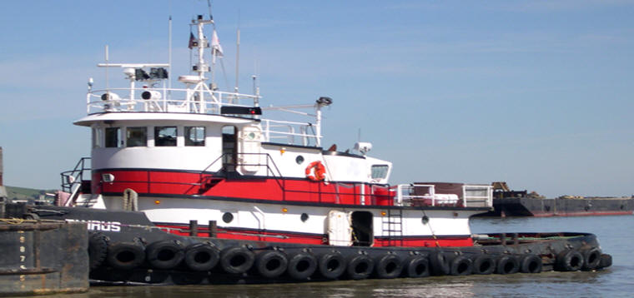

Horsepower: | Length: | Beam: | Deep Draft: | Astern Bollard: | Ahead Bollard:
1,320 | 75’ | 24’ | 8’ | 25.0 Kips | 35.0 Kips
Engines: | Rudders: |  |  | Fresh Water: | Fuel Oil:
Twin Cummins  QSK19-M | Twin |  |  | 3,000 Gal. | 21,000 Gal.
Propellers: | Main Tow Wire: |  |  | Under-Rider Wire:
Twin  Kort Nozzles | 1.5”x2500’ |  |  | 1.5”x600’
Gross Tonnage: | Call Sign: |  |  | Official Number:
116 | WDB6361 |  |  | 599924
Note:
Tank Vessel Escort Certified

