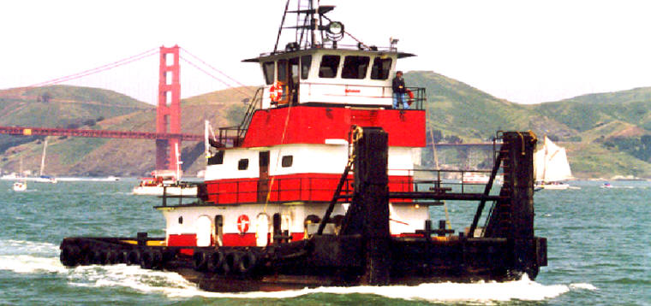

Horsepower: | Length: | Beam: | Deep Draft: | Astern Bollard: | Ahead Bollard:
2,000 | 65’ | 24’ | 8’
Engines: | Face Wires: |  |  | Fresh Water: | Fuel Oil:
Twin Cummins  KTA38-M1 | 7/8”x110’
Propellers: | Anchor Wire: |  |  | Anchor Winch:
Twin Nozzles | 7/8”x50’ |  |  | 50,000 lbs. (Bow)
Gross Tonnage: | Call Sign: |  |  | Official Number:
150 | WCY5602 |  |  | 569110
Note:

