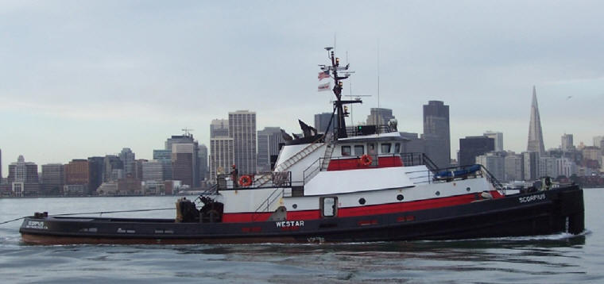

Horsepower: | Length: | Beam: | Deep Draft: | Astern Bollard: | Ahead Bollard:
3,900 | 124’ | 31’5” | 15’ | 74.94 Kips | 105 Kips
Engines: | Rudders: |  |  | Fresh Water: | Fuel Oil:
Twin EMD 16-645-E2 | Quad |  |  | 8,000 Gal. | 75,000 Gal.
Propellers: | Tow Winch: |  |  | Bow Winch:
96”x112” Nozzles | Single Drum 2,600 of 2-1/4 Wire  110,000 Lbs. at 60 FPM |  |  | 1-Drum  2-Gypsies
Gross Tonnage: | Call Sign: |  |  | Official Number:
180 | WDD8770 |  |  | 506606
Note:
Tank Vessel Escort Certified

