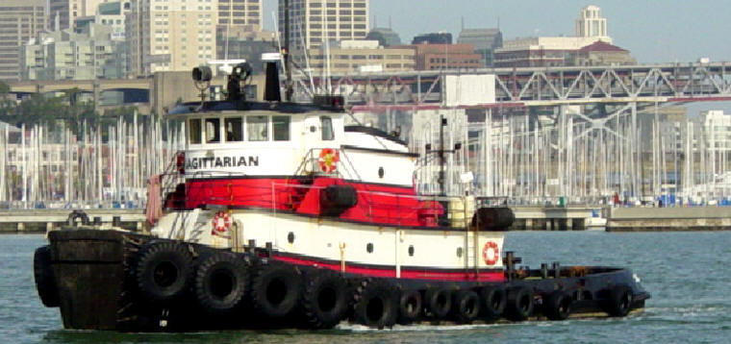

Horsepower: | Length: | Beam: | Deep Draft: | Astern Bollard: | Ahead Bollard:
3,000 | 79’ | 25’ | 11’ | 39.50 Kips | 61.11 Kips
Engines: | Face Wires: |  |  | Fresh Water: | Fuel Oil:
Twin Cummins  KTA38-M2 | 1”x110’
Propellers: | Main Tow Wire: |  |  | Under-Rider Wire:
Twin | 1.5”x1300’ |  |  | 1.5”x600’
Gross Tonnage: | Call Sign: |  |  | Official Number:
92 | WBR6265 |  |  | 600562
Note:
Tank Vessel Escort Certified

