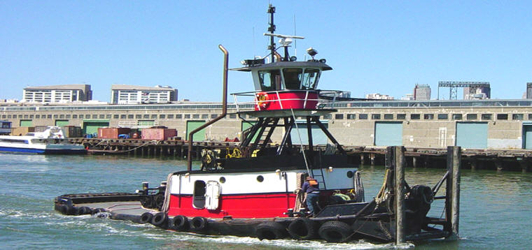

Horsepower: | Length: | Beam: | Deep Draft: | Astern Bollard: | Ahead Bollard:
1,060 | 61’5” | 18’5” | 5’5”
Engines: | Face Wires: |  |  | Fresh Water: | Fuel Oil:
Twin Cummins  KTA-1150 | 7/8”x130’
Propellers: | Anchor Wire: |  |  | Anchor Winch:
Twin | 7/8”x50’ |  |  | 50,000 lbs. (Bow)
Gross Tonnage: | Call Sign: |  |  | Official Number:
58 | WDB5945 |  |  | 262798
Note:

