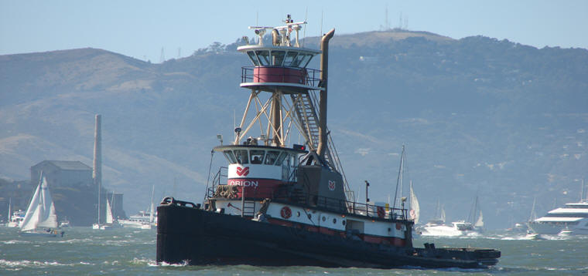

Horsepower: | Length: | Beam: | Deep Draft: | Astern Bollard: | Ahead Bollard:
3,000 | 100’ | 33’ | 12’ | 43.86 Kips | 65.53 Kips
Engines: | Rudders: |  |  | Fresh Water: | Fuel Oil:
Twin EMD  12-645-E6 | Twin
Propellers: | Plasma Pennants: |  |  | Face Wires:
Twin | Forward 40’  Aft 52’ |  |  | 1”x75’
Gross Tonnage: | Call Sign: |  |  | Official Number:
145 | WCC9851 |  |  | 583761
Note:
Tank Vessel Escort Certified

