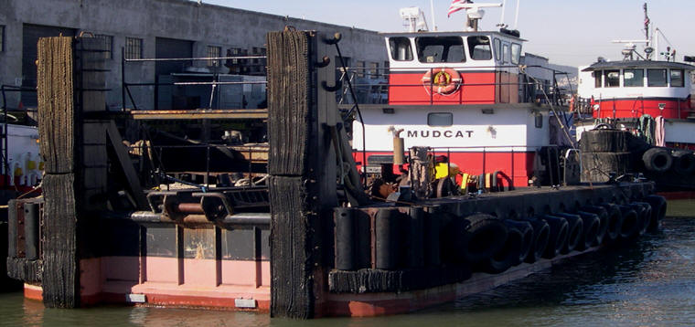

Horsepower: | Length: | Beam: | Deep Draft: | Astern Bollard: | Ahead Bollard:
880 | 72’ | 21’ | 3.5
Engines: | Face Wires: |  |  | Fresh Water: | Fuel Oil:
Twin Cummins  N14M | 7/8”x110’
Propellers: | Tow Winch: |  |  | Anchor Winch:
Twin Nozzles |  |  |  | 50,000 lbs. (Bow)
Gross Tonnage: | Call Sign: |  |  | Official Number:
56 | WCY8255 |  |  | 1067220
Note:

