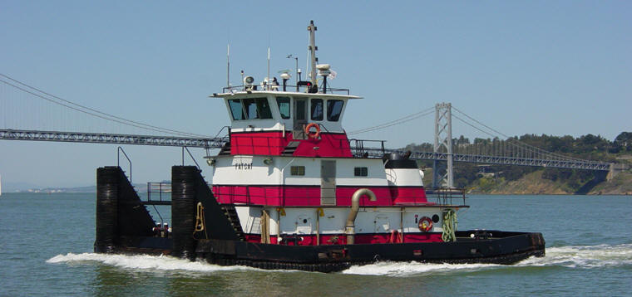

Horsepower: | Length: | Beam: | Deep Draft: | Astern Bollard: | Ahead Bollard:
1.550 | 60’ | 28’ | 8’6”
Engines: | Face Wires: |  |  | Fresh Water: | Fuel Oil:
Twin Cat.  3508B | 7/8”x75’
Propellers: | Anchor Wire: |  |  | Anchor Winch:
Twin |  |  |  | 50,000 lbs. (Bow)
Gross Tonnage: | Call Sign: |  |  | Official Number:
113 | WDA6645 |  |  | 583105
Note:

