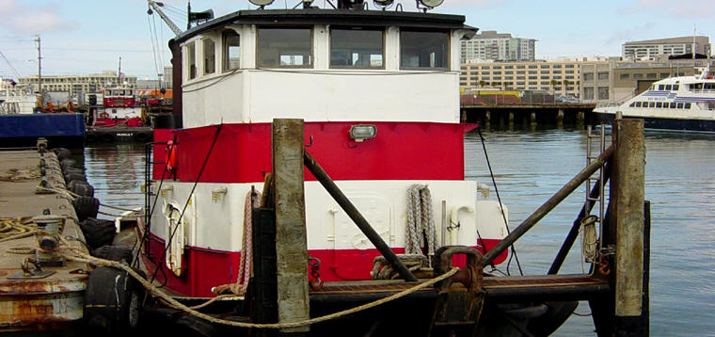

Horsepower: | Length: | Beam: | Deep Draft: | Astern Bollard: | Ahead Bollard:
1,050 | 65’ | 19’ | 5’
Engines: | Face Wires: |  |  | Fresh Water: | Fuel Oil:
Twin Cummins  KTA-1150 | 7/8”x110’
Propellers: | Anchor Wire: |  |  | Anchor Winch:
Twin | 7/8”x75’
Gross Tonnage: | Call Sign: |  |  | Official Number:
63 | WZX5454 |  |  | 521657
Note:

