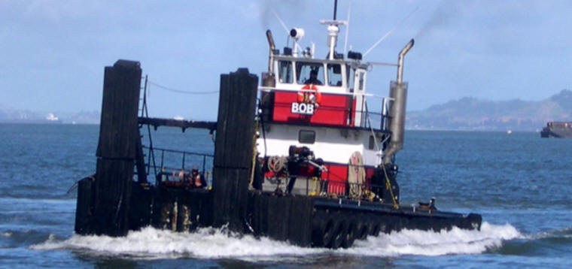

Horsepower: | Length: | Beam: | Deep Draft: | Astern Bollard: | Ahead Bollard:
950 | 71’7” | 21’ | 5’
Engines: | Face Wires: |  |  | Fresh Water: | Fuel Oil:
Twin Detroit  Series 60 | 7/8”x110’
Propellers: | Tow Winch: |  |  | Anchor Winch:
Twin Nozzles |  |  |  | 50,000 lbs. (Bow)
Gross Tonnage: | Call Sign: |  |  | Official Number:
67 | WDB5142 |  |  | 1125230
Note:

