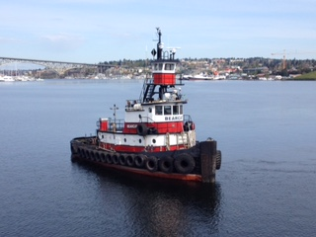

Horsepower: | Length: | Beam: | Deep Draft: | Astern Bollard: | Ahead Bollard:
1,320 | 69’ | 23’ | 9 | 17.85 Kips | 25.0 Kips
Engines: | Face Wires: |  |  | Fresh Water: | Fuel Oil:
Twin Cummins  QSK19-M | 7/8”x110’
Propellers: | Tow Winch: |  |  | Bow Winch:
Twin
Gross Tonnage: | Call Sign: |  |  | Official Number:
108 | WV8240 |  |  | 298912
Note:
Tank Vessel Escort Certified

