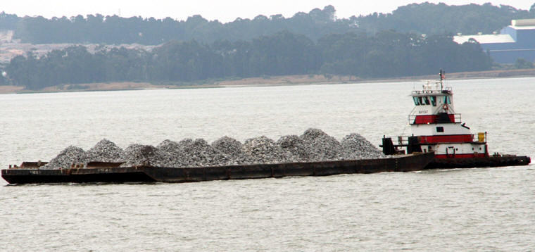

Horsepower: | Length: | Beam: | Deep Draft: | Astern Bollard: | Ahead Bollard:
950 | 60’ | 21’1” | 6’ | 10.09
Engines: | Face Wires: |  |  | Fresh Water: | Fuel Oil:
Twin Cat.  3406E | 7/8”x110’
Propellers: | Tow Winch: |  |  | Bow Winch:
Twin
Gross Tonnage: | Call Sign: |  |  | Official Number:
96 | WDA9210 |  |  | 627286
Note:

